Clemson University
Image Segmentation
Assignment 4, ECE 847
Ujwal C Naik
Assignment Number 4

Report for the 4th assignment for Digital Image Processing

Introduction:
Image segmentation is the process of partitioning an image into multiple segments/parts. The aim of image segmentation is to augment understanding of an image by changing its representation. Image segmentation is typically used to locate objects and boundaries in an image
The aim of this assignment is to implement minimum spanning tree image segmentation as mentioned in the paper –Efficient Graph Based Image Segmentation, IJCV 2004- by Pedro Falzenszwalb and Daniel Huttenlocher. The specialty of this method is that it addresses issues faced while using similar segmentation algorithms (for example Region Growing) and despite making greedy decisions produces segmentations that satisfy global properties.
Method:
Falzenszwalb and Huttenlocher have taken a graph based approach to image segmentation in this paper. For this, we must consider our image to be a graph and individual pixels to be vertices. The differences in intensities in the different color channels of the image are considered to be edges for the purpose of this implementation.
The method suggested by Falzenszwalb and Huttenlocher for image segmentation is based on the Kruskal’s minimum spanning tree algorithm where, an MST is a minimum weight, cycle free subset of a graph’s edges such that all nodes are connected.
The significance of the use of minimum spanning tree for image segmentation is that it addresses issues not answered by the region growing algorithm such as: which node to start at? Or which node to consider next? As a result it overcomes the biggest short coming of the Region Growing algorithm where most preference is given to the earlier region.
The various steps in the algorithm are as follows:
- Smoothing the image: This is an important step in the implementation of this algorithm and the image must be smoothed with at-least a small sigma value before proceeding with the rest of the algorithm. If the image isn’t smoothed the algorithm doesn’t produce desirable results.
- Building a graph from an image: Given an image we calculate the weights between the various pixels in the graph. In our implementation, we have considered the Euclidean distance between the intensities of the pixels as a measure of the weight between two pixels. The pixels are considered to be vertices in the graph and the weights are the edges that connect adjacent vertices.
- Sorting Edges: After the weights are calculated we sort the edges in ascending order of weight.
- Implementing Kruskal’s algorithm: We run Kruskal’s Minimum spanning tree algorithm on the graph with a slight modification that we merge two regions only if certain criteria are met. Hence, while running the algorithm we have a forest (ie. A set of trees). The trees store certain properties and information of the image. The trees are merged only if certain criteria are met. In particular we do not really care about the trees but rather the regions that are represented by the trees. Therefore, we need to only store the regions, that is the set of pixels, rather than the edges and other data that is generated during the course of the algorithm.
- When the algorithm finishes each individual tree represents a region in the segmented image.

Algorithm:
The algorithm for graph based image segmentation using Minimum Spanning Trees can be explained as follows:
- Smooth the Image with a 0.8 sigma value kernel to obtain desirable results from the algorithm.
- Construct graph from the image: Initialize all the pixels as vertices and calculate the edge weights between the vertices.
- Sort the edges in ascending order of weights. The edges must be sorted in order from lowest weight to the highest weight.
- Initialize the disjoint set to the size of all the pixels in the image. This is the initial state of the disjoint set where every pixel is basically in a separate set of its own.
- Now we consider adjacent sets first. The sets are checked for similarity with each other and they are merged only if certain criteria for similarity are met.
- If the sets are similar they are merge and the count on the number of sets is decremented as the two sets that were similar are merged into one single set.
- This process is carried on till all similar sets are merged and then we enforce minimum-size condition. Groups of pixels that are below a certain size are merged into larger groups to both reduce the number of regions obtained as well as reduce the noise in the output image.
RESULTS


Psuedocolor image for K= 300 and sigma 0.5
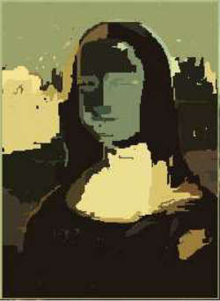
Mean image K=300 sigma=0.5
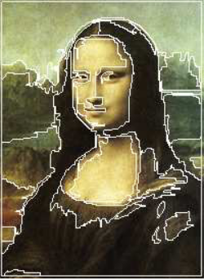
Boundaries for K=300 and sigma = 0.5

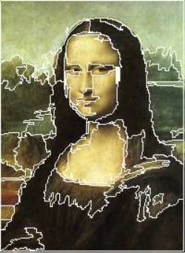
K=300 sigma=0.8
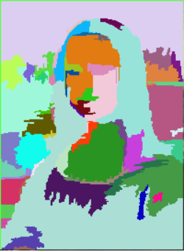
K=300 sigma = 0.8
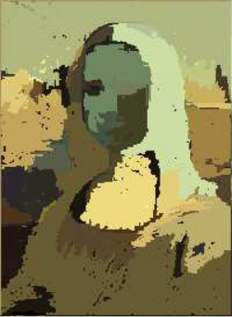
K=300 and sigma=0.8
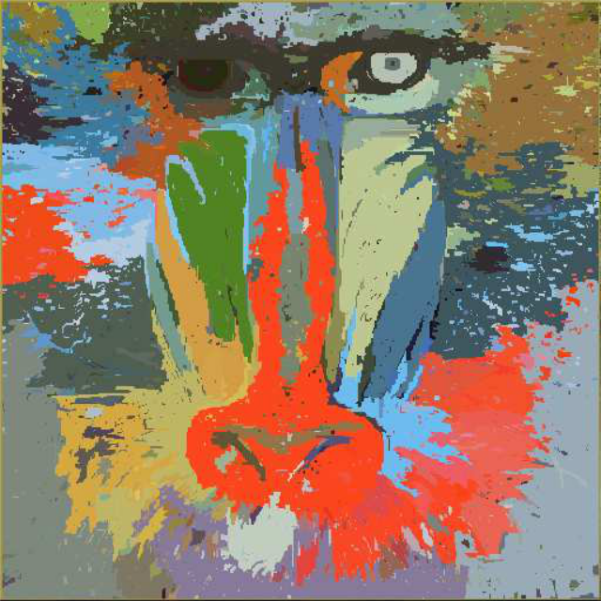
Mean image K=300 sigma=0.5
K=300 and sigma=0.8

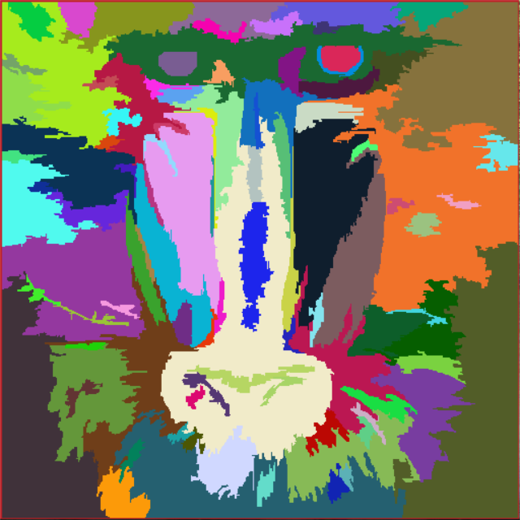
Psuedo Coloring K=300 sigma = 0.8
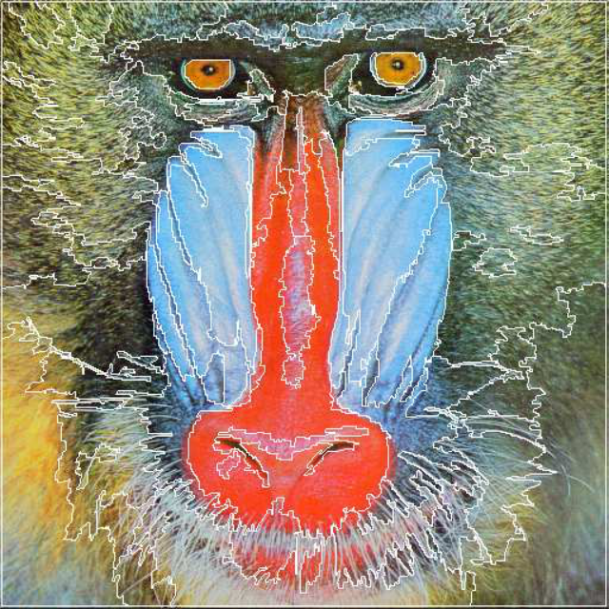K=300 and sigma=0.5
K=300 and sigma=0.8
K=300 and sigma=0.8
Conclusion
The image segmentation algorithm works satisfactorily for all inputs.
There are various factors that affect the performance of the segmentation algorithm. The values of sigma, K and minimum size all play a role in the nature of the output image.

